Medical Aid in Dying Medication Protocols, explained and compared:
Updated 12/5/19
Lonny Shavelson, M.D.

Acronyms:
DDMP2: Digitalis (50mg), Diazepam (1gm), Morphine (15gm), Propranolol (2gms).
D-DMP2: Digitalis (100mg) 30 min before other meds, then Diazepam (1gm), Morphine,
(15gms), Propranolol (2gms)
D-DMA: Digital 100mg 30 min before other meds, then diazepam (1gm), morphine (15gm),
amitriptyline (8gms).
Please see the graph below (and attached), representative of 161 patients from my practice. (Aggregate data from other practitioners, 38 patients, confirms our data).
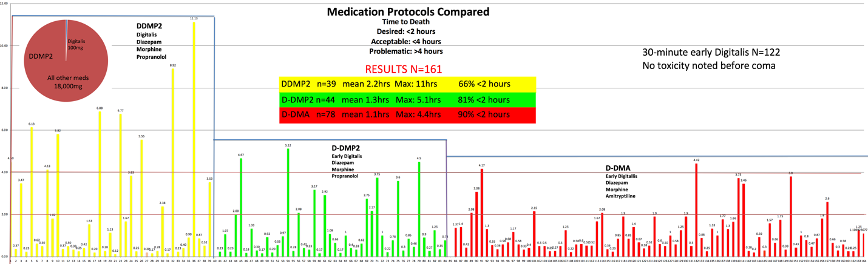
Explanation of the graph:
DDMP2 vs D-DMP2: (NOTE: The dash in D-DMP2 signifies a pause of 30 minutes between giving the digitalis and the morphine/diazepam/propranolol.) There is now very strong evidence for "Pre-digitalis.” The reason is that without giving digitalis separately, the tiny amount of digitalis (100 milligrams) gets lost amid the huge mass of the other meds (18,000 milligrams)–see the brown pie chart—and the digitalis doesn’t get absorbed. By using pre-digitalis, i.e. dig alone for 30 minutes, the dig is rapidly absorbed—providing more rapid and thorough digitalis toxicity. Using Pre-digitalis (D-DMP2 vs. DDMP2), we cut the mean times to death by 33% compared with DDMP2 (see the graph). More significantly, the maximum time to death was reduced from 11 hours to 5.1 hours. I now fully believe that separating the digitalis from our other meds should be the standard of care.
Then, more news: The reason for most of the longer deaths with D-DMP2 is that the myocardium tolerates bradycardias caused by the dig/propranolol (we use small EKG rhythm monitors with our patients, so we see the pharmacologic effects on the myocardium). We then took out propranolol and added amitriptyline, to formulate D-DMA (amitriptyline induces tachyarrhythmias and impairs cardiac contractility, as well as causing profound hypotension). And the results are again impressive: See D-DMP2 vs. D-DMA on the graph. Our times to death again dropped significantly by using D-DMA, now with 90% of deaths occurring in <2 hours. D-DMA is both faster and more reliable than D-DMP2, and markedly better than DDMP2.
In summary: D-DMP2 improves DDMP2 by 33%. D-DMA improves D-DMP2 by another 33%. Compare D-DMA with DDMP2: It's 69% better—a very significant difference.
MOST SIGNIFICANTLY: The long time-to-death outliers have been markedly decreased with D-DMA, both in total time to death and in frequency of long deaths. D-DMA has a shorter mean time to death (1.1. hours) and maximum time to death (4.4 hours).

Times to death of >2 hours are now only 10% of cases (down from 34% with DDMP2 and 19% with D-DMP2). (The lower red horizontal line on the graph is the 2-hour mark.)
(PLEASE NOTE: This does not apply to patients with multiple risk factors for prolonged deaths—see the Red Flag Checklist attached file. Remember: It doesn’t matter what medications you put into a dysfunctional stomach/duodenum—they won’t be absorbed promptly and will result in prolonged deaths. This is a problem of patient physiology, not pharmacology. For these patients, please consult with an experienced aid-in-dying practitioner to consider a change in medications and/or administration route.)
NOTE: The data below is only from our practice. We now also have D-DMA reports on 38 patients from other practitioners. Their data is quite consistent with ours. N total is 116.
Also NOTE: Another group is testing DDMA, without pre-dig. It is too soon to make conclusions from their data, but early reports of long deaths have come in. As of this writing, in my opinion, D-DMA should be used until more significant data is in about DDMA.
A comment re fears of using pre-digitalis because the patient may experience digitalis toxicity while still awake. This is a theoretical concern, but it hasn’t played out in a single case in our practice or others. With combined D-DMP2 and D-DMA we now have 160 early-dig patients from multiple practices, without a single complication or failure to take the sedatives after taking pre-dig. The theoretical concern about early digitalis administration has proven not to be of clinical significance.
The graph below is also attached as a separate file so that you can see it larger on your screens. Thicker horizontal lines are 2 and 5 hours. Each vertical line is a patient.
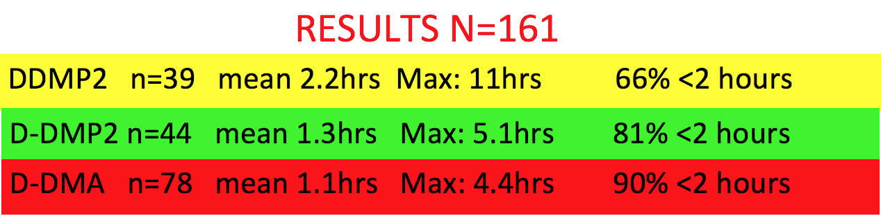
In my opinion, the data clearly shows the advantage of D-DMA over D-DMP2 (just as D-DMP2 is better than DDMP2).
At this time, when asked, I’m recommending D-DMA as the regimen of choice for uncomplicated medical aid in dying. (For complicated medical aid in dying, i.e. those patients who have multiple risk factors for prolonged deaths, I recommend consultation to individualize the medication regimen and/or route for that particular patient.)
The final decision is, of course, up to each practitioner. But I believe the standard of care for medical-aid-in-dying pharmacology is now D-DMA.
I welcome all thoughts and comments.
Thank you!
Lonny
Lonny Shavelson, M.D.

