Medical Aid in Dying Medication Protocols, explained and compared:
Updated 7/8/20
Lonny Shavelson, M.D.

This is a Pharmacology of Aid in Dying update. (Nerd alert)
(for an explanation and history of these protocols, please see the update of 12/15/19)

End of Life Choices Oregon just released its July 1, 2020 data update (thank you to Peter Lyon, MD, and Bill Southworth, MD, among others). End of Life Washington has recently done the same. I (Lonny) have been gathering data from Bay Area End of Life Options (BAELO in the data sheet), as well as data from other California practitioners.

Which provides a unique opportunity to look at up-to-date aggregate data from multiple sources, of different aid-in-dying medication protocols--and come to some clear conclusions.

A reminder of our obscure nomenclature:
DDMP2 (Digitalis, Diazepam, Morphine, Propranolol)
DDMA (Digitalis, Diazepam, Morphine, Amitriptyline)
D-DMA (Digitalis 30 minutes in advance, then Diazepam, Morphine, Amitriptyline)

Here are the most crucial numbers, relating to Time to Death from ingestion (in hours). (Feel free to skip to the graphed summaries below the data.)

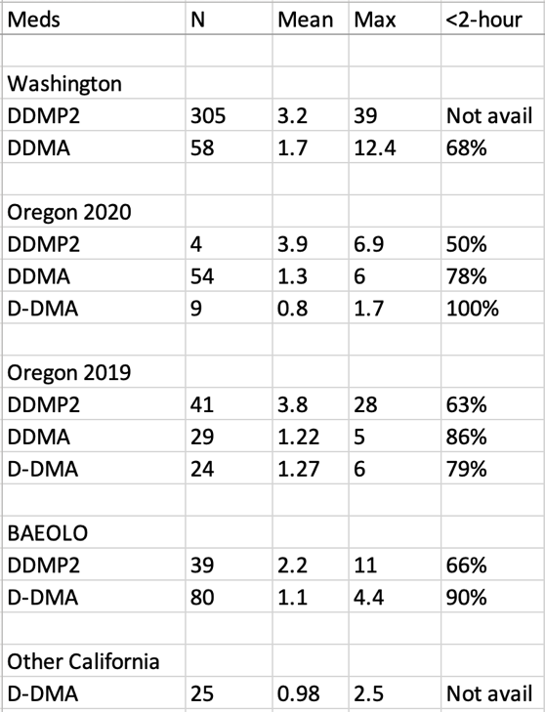

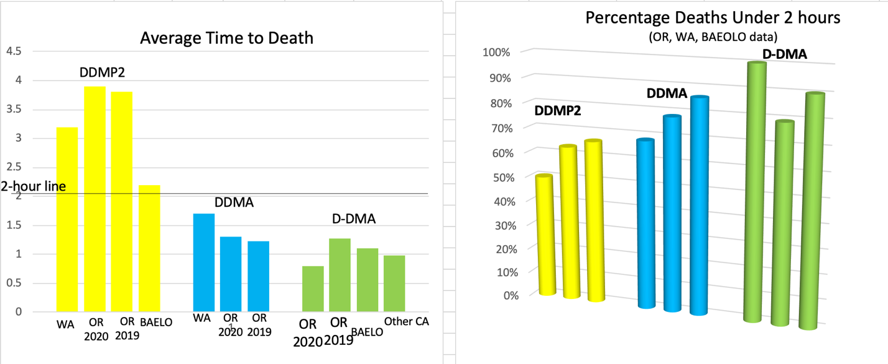

Quick summary: (NOTE: This is my description and personal opinion, not any formal conclusion on the part of the Academy.)

DDMP2 is markedly and consistently inferior to DDMA or D-DMA, across multiple data sources. In my opinion, DDMP2 should be retired from use, with gratitude for its long, valuable service. The data is now extensive and consistent enough that continued use of DDMP2 should be considered well below Best Practices.

More interesting: DDMA and D-DMA are in a tight race, with D-DMA looking consistently better, but not with a major difference. I would say that at this point in time, practitioners who are able to work with the separate/early dose of digitalis (D-DMA), should do so. Those who find the extra step of using "early digitalis" to be difficult for patients to work with (i.e. in deaths not attended by a health professional or experienced volunteer), and whose patients are willing to accept a slightly longer time to death and increased risk of a prolonged death, should use DDMA. Both regimens are well within Best Practices.

In summary, updated data this month from multiple sources confirms, I believe:

D-DMA when possible.
DDMA if D-DMA is not practical.
D-DMP2 No.

These are my own conclusions, not an official position of the Academy. All practitioners should, of course, form their own conclusions from the data.

Thank you!!

Lonny

