Rectal administration of aid in dying medications

Supplies:
20-22fr foley catheter with a three-way stop cock (Lopez enteral valve), and a 100mL catheter tipped syringe, and a 30mL Luer lock syringe to inflate the balloon. See the attached picture

(all available on Amazon)

- stop-cock (lopez)
- https://www.amazon.com/gp/product/B003MWSEZ6/ref=ppx_yo_dt_b_asin_title_o04_s00?ie=UTF8&psc=1

- 100mL cath tipped syringe (non-medical/non-sterile):

https://www.amazon.com/Syringes-Scientific-Nutrient-Measuring-Refilling/dp/B07CG8BV9C/ref=sr_1_9?crid=2WKEB5460STJX&keywords=100ml+syringe&qid=1564778466&s=industrial&sprefix=100ml+%2Cindustrial%2C176&sr=1-9

- catheter 22fr, 30mL - I like a slightly smaller bore but I couldn't find one on amazon with a 30mL balloon:
https://www.amazon.com/Medline-Industries-DYND11536-Silicone-Catheters/dp/B00TPI1DTU/ref=sr_1_fkmr0_1?keywords=2-Way+Silicone+Foley+Catheters%2C+22FR%2C+30+mL&qid=1564778770&s=gateway&sr=8-1-fkmr0

- 30mL leur lock syringe for balloon

Pre-care: An intact, empty, warm, moist, well perfused rectum assures thorough absorption of rectally administered aid in dying medications. Be sure your patient has good bowel care in the 72 hours before aid in dying. A daily soft BM is good, but liquid stool is contraindicated. A small amount of firm stool in the rectum is OK. Best practice is to do an enema the day before or the morning of AID.

Procedure

1. Rectal exam - make certain there is access for meds - no new tumors blocking passage, and no accumulated stool in the rectal vault. If needed, use enema or disimpact.

2. Insert the assembled catheter at least 6 inches into the rectum, inflate the balloon to 20mLs (requires a Leur syringe!), and gently tug the balloon back against internal sphincter to seal rectum.

3. Thread the port/stop-cock end of the catheter up between the legs, along the perineum, up through to the waist (not along the side of the thigh as this makes occlusion of the catheter more likely). Pants or undergarments can be pulled up over this, and the port/stopcock can be accessed at the waistline.
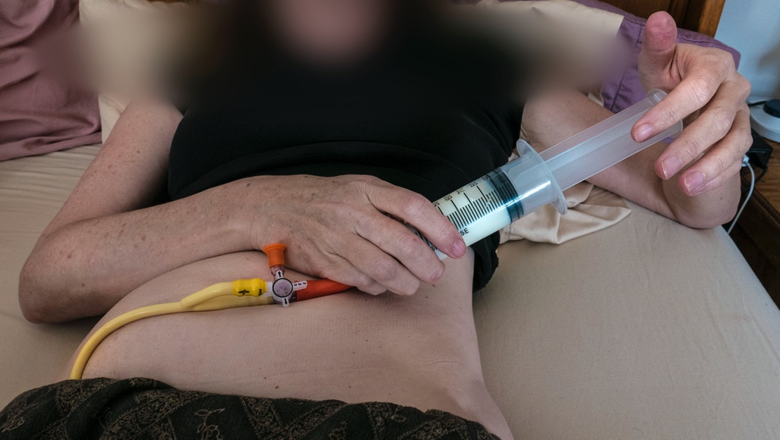

4. Med administration, pre-fill syringes with no more than 100mls of liquid. Most patients can tolerate about 100mLs (per surge) without stimulating any contractions which might expel the meds. You may need to assist with attaching the catheter tipped syringe into the stop-cock outlet, opening the valve properly by turning the stopcock, and guiding patient to slowly depress the plunger to self-administer. Then turn the stopcock (close the valve) and remove the syringe, so meds don't leak out. (we have not bothered with flushes, as the catheter holds less than 3mLs total).
- antiemetic pre-meds can be dissolved in 2oz warm water. Administer this 45 minutes before digitalis.
-mix the digitalis with 2oz (60mLs) filtered apple juice. Patients administer this 30 minutes before the DMA.
- mix the DMA with 90-95mLs of filtered apple, or until the volume adds up to no more than 100mLs.

5. Time to sleep and time to death has not varied much from oral administration; 3-10 to deep sleep, and 2-4 hrs to death. Families may benefit with support through the normal signs and symptoms of dying including agonal breathing, changes in color, etc.…

Post mortem care:
Do not remove catheter ostmortem - so that no leakage occurs.

