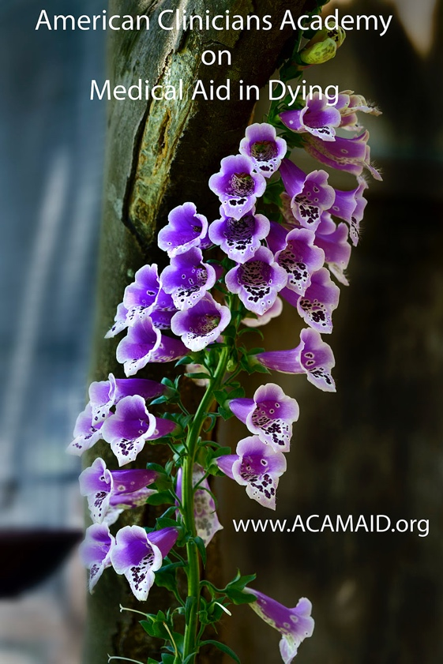
Lonny Shavelson, MD
Chair
American Clinicians Academy on Medical Aid in Dying

October 21, 2020

A reminder about amitriptyline causing oropharyngeal/esophageal burning:

When using any of the aid-in-dying formulas that contain amitriptyline (D-DMA, DDMA), it's important to remember that amitriptyline causes some oropharyngeal/esophageal burning. This is a chemical irritant effect, not due to acidity, so it is not relieved by antacids.

We now have extensive experience and reports with these compounds, and have found that:
- A mild burning effect is common, severe burning is not--roughly 10% or so of patients. (NOTE: This is independent of the bad taste of all aid-in-dying formulas, which is noted by almost all patients, although most say something like "It's terrible, but tolerable.")
- The most important factor in working with this is to advise the patient in advance that there may be burning. If the patient is surprised by the burning, it is much more severe and upsetting. As with any medical procedure, detailed information and calm reassurance before, during, and after ingestion are essential. And in this case, also advise the patient that any discomfort is quite brief -- typically only a few minutes before analgesia and unconsciousness. (If a clinician is not present at the bedside, this information should be conveyed by verbal and written instructions before ingestion.)
- Calmly instruct the patient that stopping the ingestion mid-way only makes it worse by creating a more prolonged mucosal exposure to the amitriptyline. It also delays the administration of soothing sorbet (see below). Encourage the patient to continue swallowing and relief is on the way as soon as full ingestion of the medications is completed.
- Immediately administer sorbet to cool down the burning. This has many positive effects: The cold and sweetness are quite pleasant and soothing. And if spooned up to the patient by someone they are close to, it has an added effect of a loving act just before the patient loses consciousness. Patient/family instructions should include having sorbet at the bedside, ready to cool down any burning. (NOTE: Sucking/chewing on a popsicle is also effective.)
- For the rare severe burning, calm reassurance that it is brief is extremely helpful, as are continued spoonfuls of sorbet. (Be careful to limit total volume, since gastric distension can cause vomiting.)
Yes, I know this all sounds terrible, and makes one wonder why we use the amitriptyline. First, extensive data shows that having amitriptyline as part of the aid-in-dying medications leads to more reliable results, significantly decreasing the risk of prolonged deaths. When patients are offered medications that are less reliable but taste somewhat better and don't burn, they invariably select reliability.

Again, as in all medical procedures, providing thorough information in a calm and reassuring way is extremely helpful. In my experience and in reports from other clinicians who follow the recommendations above, it is quite uncommon to have significant distress from formulas that include amitriptyline.

We welcome other opinions, ideas, and clinical experiences on this topic.

Thank you.

